Java Problemsheet - 10

Name: Kaaviya S S Roll. no: 22PT15

1. Write a program to store employee data using collection object called ArrayList. Also,
perform the operations like Find the employees age over 50, Print the employees from USA and Sort the employees by country.

import java.util.ArrayList;
import java.util.Collections;
import java.util.Comparator;
import java.util.List;

class Employee {
private String name;
private int age;
private String country;

// Constructor
public Employee(String name, int age, String country) {
this.name = name;
this.age = age;
this.country = country;
}

public String getName() {
return name;
}
public int getAge() {
return age;
}
public String getCountry() {
return country;
}

@Override
public String toString() {
return "Name: " + name + ", Age: " + age + ", Country: " + country;
}
}

public class EmployeeManagement {
public static void main(String[] args) {

List<Employee> employees = new ArrayList<>();

employees.add(new Employee("Alice", 45, "USA"));
employees.add(new Employee("Bob", 52, "Canada"));
employees.add(new Employee("Charlie", 55, "USA"));
employees.add(new Employee("David", 38, "India"));
employees.add(new Employee("Eve", 60, "Germany"));
employees.add(new Employee("Frank", 49, "USA"));
employees.add(new Employee("Grace", 65, "UK"));

// Find employees aged over 50
System.out.println("Employees aged over 50:");
for (Employee emp : employees) {
if (emp.getAge() > 50) {
System.out.println(emp);
}
}

// Print employees from the USA
System.out.println("\nEmployees from USA:");
for (Employee emp : employees) {
if (emp.getCountry().equalsIgnoreCase("USA")) {
System.out.println(emp);
}
}

// Sort employees by country and print the sorted list
Collections.sort(employees, Comparator.comparing(Employee::getCountry));
System.out.println("\nEmployees sorted by country:");
for (Employee emp : employees) {
System.out.println(emp);
}
}
}

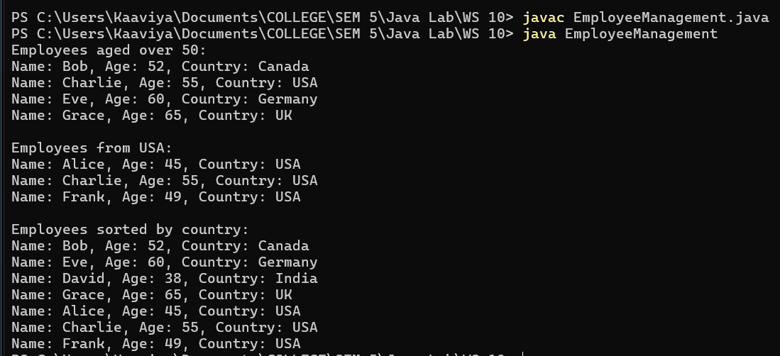

—----------------------------------------------------------------------------------------------------------------------------

2. Write a method minToFront(list) that takes an ArrayList of integers as a parameter and that moves the minimum value in the list to the front, otherwise preserving the order of the elements. For example, if available called list stores the following values: {3, 8, 92, 4, 2, 17, 9} and you make this call: minToFront(list); it should store the following values after the call: {2, 3, 8, 92, 4, 17, 9}. You may assume that the list stores at least one value.

import java.util.ArrayList;

public class MinToFront {

public static void minToFront(ArrayList<Integer> list)
{
if (list == null || list.size() < 1) {
return;
}

int minIndex = 0;
int minValue = list.get(0);
for (int i = 1; i < list.size(); i++) {
if (list.get(i) < minValue) {
minValue = list.get(i);
minIndex = i;
}
}

// Remove the min val from its current position
list.remove(minIndex);

// Add the min val at the front (index 0)
list.add(0, minValue);
}

public static void main(String[] args) {
// Example list
ArrayList<Integer> list = new ArrayList<>();
list.add(3);
list.add(8);
list.add(92);
list.add(4);
list.add(2);
list.add(17);
list.add(9);

System.out.println("Before minToFront: " + list);
minToFront(list);
System.out.println("After minToFront: " + list);
}
}

—----------------------------------------------------------------------------------------------------------------------------

3. Write a Java program to include a method called removeZeroes that takes as a parameter an ArrayList of integers and eliminates any occurrences of the number 0 from the list. For example, if the list stores the values (0, 7, 2, 0, 0, 4, 0) before the method is called, it should store the values (7, 2, 4) after the method finishes executing.

import java.util.ArrayList;

public class RemoveZeroes {

public static void removeZeroes (ArrayList<Integer> list)
{
if (list == null || list.size() < 1) {
return;
}

for (int i = list.size()-1; i>=0; i--) {
if (list.get(i) == 0) {
list.remove(i);
}
}
}

public static void main(String[] args) {

ArrayList<Integer> list = new ArrayList<>();
list.add(0);
list.add(7);
list.add(2);
list.add(0);
list.add(0);
list.add(4);
list.add(0);

System.out.println("Before RemovingZeroes: " + list);
removeZeroes(list);
System.out.println("After RemovingZeroes: " + list);
}
}

—----------------------------------------------------------------------------------------------------------------------------

4. Write a program to find the duplicate elements stored in HashSet.

import java.util.HashSet;
import java.util.Scanner;

public class FindDuplicates {
public static void main(String[] args) {

Scanner obj = new Scanner(System.in);

// HashSet to store unique elements
HashSet<Integer> uniqueSet = new HashSet<>();
// HashSet to store duplicate elements
HashSet<Integer> duplicateSet = new HashSet<>();

System.out.print("Enter the no. of elements: ");
int n = obj.nextInt();

System.out.println("Enter the elements: ");
for(int i=0; i<n; i++)
{
int element = obj.nextInt();
if (!uniqueSet.add(element)) {
duplicateSet.add(element);
}
}

System.out.println("Duplicate elements: " + duplicateSet);
obj.close();
}
}

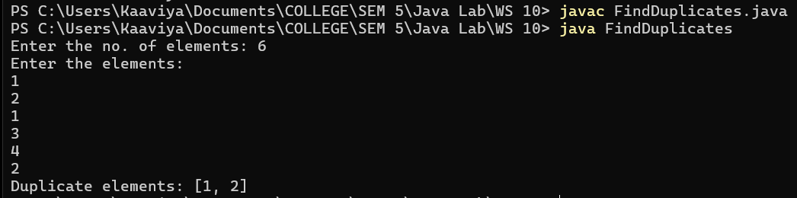

—----------------------------------------------------------------------------------------------------------------------------

5. Write a program to find the numbers greater than 50 and smallest and largest number in the array. Use TreeSet collection object.

//TreeSet automatically sorts the elements in natural order (ascending),
//which makes it easier to retrieve the smallest and largest numbers.

import java.util.TreeSet;

public class TreeSetRetrieval {

public static void main(String[] args) {

int[] numbers = {25, 60, 45, 10, 95, 30, 78, 50, 2, 85};

TreeSet<Integer> numberSet = new TreeSet<>();

for (int num : numbers) {
numberSet.add(num);
}

// Find the smallest and largest number
int smallest = numberSet.first();
int largest = numberSet.last();

TreeSet<Integer> greaterThan50 = (TreeSet<Integer>) numberSet.tailSet(51); // All numbers greater than 50

System.out.println("Original numbers: " + numberSet);
System.out.println("Smallest number: " + smallest);
System.out.println("Largest number: " + largest);
System.out.println("Numbers greater than 50: " + greaterThan50);
}
}

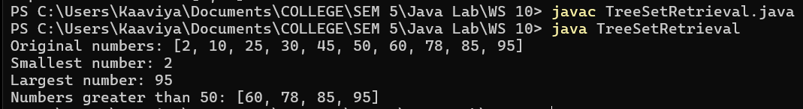

—----------------------------------------------------------------------------------------------------------------------------

6. Write a program to find the highest stock price, average of stock price and remove the companies with stock price below 50.

import java.util.TreeSet;

public class StockPrice {
public static void main(String[] args) {

double[] stockPrices = {45.5, 72.0, 30.5, 55.5, 85.0, 22.3, 60.0, 49.9, 100.0, 50.5};

TreeSet<Double> stockSet = new TreeSet<>();
for (double price : stockPrices) {
stockSet.add(price);
}

// Remove companies with stock price below 50
stockSet.removeIf(price -> price < 50);

// Highest stock price
Double highestPrice = stockSet.isEmpty() ? null : stockSet.last();

// Average stock price
double sum = 0;
for (double price : stockSet) {
sum += price;
}
double averagePrice = stockSet.isEmpty() ? 0 : (sum / stockSet.size());

// Display results
System.out.println("Given stock prices: ");
for (double price : stockPrices)
System.out.print(price + " ");
System.out.println();
System.out.println("Remaining stock prices (>= 50): " + stockSet);
System.out.println("Highest stock price: " + highestPrice);
System.out.println("Average stock price: " + averagePrice);
}
}

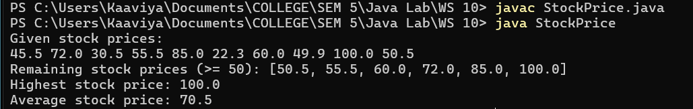

—----------------------------------------------------------------------------------------------------------------------------

7. Write a method that takes a string and returns the number of unique characters in the string. It is expected that a string with the same character sequence may be passed several times to the method. Since the counting operation can be time consuming, the method should cache the results, so that when the method is given a string previously encountered, it will simply retrieve the stored result. Use collections and maps where appropriate.

import java.util.HashMap;
import java.util.HashSet;

public class UniqueCharacterCounter {

private static HashMap<String, Integer> cache = new HashMap<>();
public static void main(String[] args) {
String str1 = "hello";
String str2 = "world";
String str3 = "hello"; //retrieve from cache
String str4 = "java programming";

System.out.println("Unique characters in " + str1 + ": " + countUniqueCharacters(str1));
System.out.println("Unique characters in " + str2 + ": " + countUniqueCharacters(str2));
System.out.println("Unique characters in " + str3 + ": " + countUniqueCharacters(str3));
System.out.println("Unique characters in " + str4 + ": " + countUniqueCharacters(str4));
}

public static int countUniqueCharacters(String str) {

if (cache.containsKey(str)) {
return cache.get(str);
}

HashSet<Character> uniqueChars = new HashSet<>();
for (char c : str.toCharArray()) {
uniqueChars.add(c);
}

int uniqueCount = uniqueChars.size();
cache.put(str, uniqueCount);

return uniqueCount;
}
}

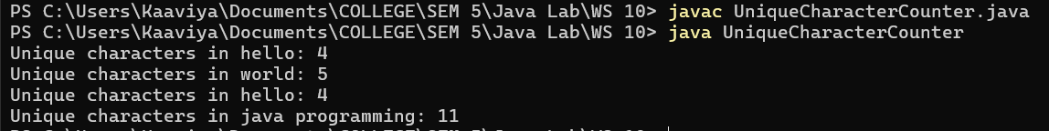

—----------------------------------------------------------------------------------------------------------------------------

8. Design a PhoneBook using a HashMap to store contact information, where the key is the contact name, and the value is the phone number. The program presents a menu with the following options:
Add Contact: Allows you to add a new contact to the phone book.
Lookup Contact: Lets you search for a contact by name and displays their phone number.
List: Display all the contacts from the phone Book
Edit: Allows to edit the phone number of the given name.
Sort: Display sorted list of all the contacts from the phone Book

import java.util.*;

public class PhoneBook {

public static HashMap<String, String> phoneBook = new HashMap<>();

public static void addContact(Scanner obj) {
System.out.print("Enter contact name: ");
String name = obj.nextLine();
System.out.print("Enter phone number: ");
String phone = obj.nextLine();

if (phoneBook.containsKey(name)) {
System.out.println("Contact already exists.");
}
else {
phoneBook.put(name, phone);
System.out.println("Contact added successfully.");
}
}

public static void lookupContact(Scanner obj) {
System.out.print("Enter contact name to lookup: ");
String name = obj.nextLine();

if (phoneBook.containsKey(name)) {
System.out.println("Phone number for " + name + ": " + phoneBook.get(name));
}
else {
System.out.println("Contact not found.");
}
}

public static void listContacts() {
if (phoneBook.isEmpty()) {
System.out.println("PhoneBook is empty.");
}
else {
System.out.println("Contacts in PhoneBook:");
phoneBook.forEach((name, phone) -> System.out.println(name + ": " + phone));
}
}

public static void editContact(Scanner obj) {
System.out.print("Enter the contact name to edit: ");
String name = obj.nextLine();

if (phoneBook.containsKey(name)) {
System.out.print("Enter new phone number for " + name + ": ");
String newPhone = obj.nextLine();
phoneBook.put(name, newPhone);
System.out.println("Phone number updated successfully.");
}
else {
System.out.println("Contact not found.");
}
}

public static void sortContacts() {
if (phoneBook.isEmpty()) {
System.out.println("PhoneBook is empty.");
}
else {
ArrayList<String> sortedKeys = new ArrayList<>(phoneBook.keySet());
Collections.sort(sortedKeys); // Sort keys alphabetically

// Display sorted contacts
System.out.println("Sorted Contacts in PhoneBook:");
for (String key : sortedKeys)
System.out.println(key + ": " + phoneBook.get(key));
}
}

public static void main(String[] args) {
Scanner obj = new Scanner(System.in);
int choice = 0;

while(true){
System.out.println("\nPhoneBook Menu:");
System.out.println("1. Add Contact");
System.out.println("2. Lookup Contact");
System.out.println("3. List Contacts");
System.out.println("4. Edit Contact");
System.out.println("5. Sort Contacts");
System.out.println("6. Exit");

System.out.print("Enter your choice: ");
choice = obj.nextInt();
obj.nextLine(); // Clear the newline

if(choice==1)
addContact(obj);
else if (choice==2)
lookupContact(obj);
else if (choice==3)
listContacts();
else if (choice==4)
editContact(obj);
else if (choice==5)
sortContacts();
else if (choice==6) {
System.out.println("Exiting phonebook...");
break;
}
else
System.out.println("Enter a valid choice!");
}

obj.close();
}
}





